Streamlined dengue clinical data capture in the hospital setting – case report form


© World Health Organization 2026
Some rights reserved. This work is available under the Creative Commons Attribution-NonCommercial-ShareAlike 3.0 IGO licence (CC BY-NC-SA 3.0 IGO; https://creativecommons.org/licenses/by-nc-sa/3.0/igo).
…

Contents
Introduction 1
Defining routine patient-focussed data elements for dengue 1
Methods 2
Declarations of interest 2
Explicit focus and scope of the case report form 2
Development process 2
Results 3
References 4
Annex A: Development process 5
Annex C: Declarations of interest 6
Annex D: Distribution of experts 7
Expert numbers by region 7
Annex E: Survey variables 8
Initial survey variables (before consensus group meetings) 8
Final consensus-agreed variables 8
Annex F: Survey results 9
Annex G: Summary of proposed clinical surveillance tools 11
Aims 11
What data? 11
Facility data to understand health system resource availability and use for treating patients with dengue: 11
Dengue patient data to capture clinical characteristic, treatment and outcomes: 11
The project will deliver… 11
Intended users 11
Key principles 11
Trusted and locally owned 11
Quick to implement and use (lightweight) 12
Promoting end-user uptake of information 12
Project timeline 12
December 2025: Finalise definitions and data 12
January 2026: Site identification for pilot 12
March - May 2026: Pilot implementation 12
Annex H: Variable completion notes 13

Acknowledgements
This publication was developed by the WHO technical teams within the WHO Health Emergencies Programme, Geneva: Antoine Chaillon, Janet V Diaz, Ilich de la Hoz-Siegler, Firdavs Kurbonov, Ingrid Rabe, Diana Rojas, Jamie Rylance.
WHO regional offices technical leads: Samuel Chong (WHO Regional Office for the Western Pacific); Gary Kuniyoshi (WHO Regional Office for the Eastern Mediterranean); John Masina (WHO Regional Office for Africa); Dina Pfeiffer (WHO Regional Office for Europe); Angel Rodriguez (Pan American Health Organization); Pushpa Wijesinghe (WHO Regional Office for the Eastern Mediterranean)
Chair: Daniel Munblit (King’s College London, United Kingdom of Great Britain and Northern Ireland)
Special thanks
- Anastasia Demidova (King’s College London, United Kingdom of Great Britain and Northern Ireland) for support in the organization and collation of expert feedback.
- Nicki Tiffin (University of the Western Cape, Cape Town, South Africa) for data science expertise
Expert panel
- Kayan Abukhaizaran (HeRAMS, Jerusalem, Occupied Palestinian Territory)
- Ruhai Bai (Nanjing University of Science and Technology, Nanjing, China)
- Harlan Campbell (University of British Columbia, Vancouver, Canada)
- Orlando Cuéllar Cuéllar (Universitario San Juan De Dios, Santa Cruz De La Sierra, Bolivia)
- Ismaël Diallo (University Joseph Ki-Zerbo, Ouagadougou, Burkina Faso)
- Cristina Domingo-Carrasco ( Robert Koch Institute, Berlin, Germany)
- Pillaveetil Sathyadas Indu (Kerala University of Health Sciences, Kerala, India)
- Emilie Javelle (French Armed Forces Health Services, Marseille, France)
- Yee-Sin Leo (National Centre for Infectious Diseases, Singapore, Singapore)
- Lucy Chai See Lum (University of Malaya, Kuala Lumpur, Malaysia)
- Maria-Lauretta Chito Orji (Alex Ekwueme Federal University Teaching Hospital, Abakaliki, Nigeria)
- Louise Thwaites (Oxford University Clinical Research Unit, Ho Chi Minh City, Vietnam)
- Nicki Tiffin (University of the Western Cape, Cape Town, South Africa)
- Maria Esterlita V Uy (National Institutes of Health, Manila, Philippines)
- Ananda Wijewickrama (University of Moratuwa, Katubedda, Sri Lanka)
- Jie Yang (Harvard Medical School, Boston, USA)

Expert reviewers
- Sudeep Adhikari (Oxford University Clinical Research Unit, Kathmandu, Nepal);
- Eka Airlangga (Universitas Muhammadiyah Sumatera Utara, Medan, Indonesia);
- Tahmina Alam (International Centre for Diarrhoeal Disease Research, Bangladesh (icddr,b), Dhaka, Bangladesh);
- Carlos Alexandre Antunes de Brito (Federal university of Pernambuco, Pernambuco, Brazil);
- Eggi Arguni (Universitas Gadjah Mada, Yogyakarta, Indonesia);
- Mirza Yousef Baig (Ziauddin University, Karachi, Pakistan);
- Aleksandra Barac (University of Belgrade, Belgrade, Serbia);
- Diego Bastos Porto (Federal University of Ceara, Fortaleza, Brazil);
- Domenico Benvenuto (University of Verona, Verona, Italy);
- Sangeeta Bhusal (National public health laboratory, Kathmandu, Nepal);
- Hans Martin Bosse (University of Düsseldorf, Düsseldorf, Germany);
- Stephanie Buchholz (European Medicines Agency, Amsterdam, Kingdom of the Netherlands);
- Jonathan Cattrall (University of Oxford, Oxford, United Kingdom of Great Britain and Northern Ireland);
- Juan Carlos Celis Salinas (Hospital regional de Loreto, Iquitos, Peru);
- Ronaldo Claure del Granado (Caja nacional de salud, Cochabamba, Plurinational State of Bolivia);
- Caroline de Araujo Mariz (Fiocruz, Pernambuco, Brazil);
- Cristina Domingo-Carrasco (Robert Koch Institute, Berlin, Germany);
- Vicente Estrada (Hospital clinico San Carlos, Madrid, Spain);
- Claudia Figueiredo Mello (Instituto de infectologia Emílio Ribas, São Paulo, Brazil);
- Ha Thi Hai Duong (Hospital for Tropical Diseases, Ho Chi Minh City, Viet Nam);
- Madiha Hashmi (Ziaddin University, Karachi, Pakistan);
- Ruth Jimbo-Sotomayor (Pontificia universidad católica del Ecuador, Quito, Ecuador);
- Philip Erick Wikman Jorgensen (Hospital clinico San Carlos, Madrid, Spain);
- Siew Wah Lee (Hospital Tengku Ampuan Rahimah, Selangor, Malaysia);
- Yi Lin Lee (Institute for clinical research, Kuala Lumpur, Malaysia);
- Neelika Malavige (University of Sri Jayewardenepura, Gangodawila, Sri Lanka);
- Kishore Mangal (Fortis Escorts hospital, Jaipur, India);
- Martin Martinot (Hopitaux civils de Colmar, Colmar, France);
- Mauro Martins Teixeira (Universidade federal de Minas Gerais, Belo Horizonte, Brazil);
- Mohd Zulfakar Mazlan (Universiti Sains Malaysia, Kelantan, Malaysia);
- Angela McBride (University of Oxford, Oxford, United Kingdom of Great Britain and Northern Ireland);
- Varistha Metem (Mahidol University, Bangkok, Thailand);
- Isabelle Meyer-Andrieux (Novartis, Basel, Switzerland);
- Catarina Oliveira Paulo (Hospital Garcia de Orta, Almada, Portugal);
- Xuan Kuan Pei (National Institutes of Health, Kuala Lumpur, Malaysia);
- Sarah Pett (University College London, London, United Kingdom of Great Britain and Northern Ireland);
- Maria Pokorska-Śpiewak (Medical Univesity of Warsaw, Warsaw, Poland);
- Mutia Rahardjani (Oxford university clinical research unit, Jakarta, Indonesia);
- Elsa Marina Rojas Garrido (Centro de atención y diagnóstico de enfermedades infecciosas , Bucaramanga, Colombia);
- Monira Sarmin (International Centre for Diarrhoeal Disease Research, Bangladesh (icddr,b), Dhaka, Bangladesh);
- Alfonso Sucerquia-Hernandez (The George Washington University, Arlington, VA, United States of America);
- Evelina Tacconelli (University of Verona, Verona, Italy);
- Ema Talarek (Medical Univesity of Warsaw, Warsaw, Poland);
- Dong Thi Hoai Tam (Oxford university clinical research rnit, Ho Chi Minh City, Viet Nam); Tun-Linn Thein (National centre for infectious diseases, Singapore, Singapore);
- Sam Tweed (University of Liverpool, Liverpool, United Kingdom of Great Britain and Northern Ireland);
- Annalise Unsworth (Westmead Hospital, Westmead, Australia);
- Alessandro Visentin (University of Verona, Verona, Italy)

Introduction
Dengue places a substantial and growing burden on health systems worldwide. Epidemiological surveillance is advancing, as is our understanding of the national and international patterns of disease. The WHO dengue dashboard reports and allows exploration of global cases and mortality (1).
High-quality clinical management can improve outcomes from dengue and other arboviruses (2). Within research, many efforts have been made to improve the collection and harmonisation of data through core outcome sets (3) and case report tools from ISARIC (4) and resulting in cohort data which describe fine-grained clinical characteristics (5). Similar efforts for Zika and other arboviruses are also underway (6,7).

Defining routine patient-focussed data elements for dengue
Despite the tools for research, many countries and facilities are unable to collect data to assess or improve patient outcomes as the data collection tools are onerous and not designed for routine practice. Guidelines for medical care of patients with dengue have been published and recently updated by the World Health Organization (8,9). However, without appropriate clinical data capture in routine (rather than research) facilities, there is a large knowledge gap, and a missed opportunity. Defining and monitoring patients’ disease severity and outcomes could empower local and national quality improvement programmes.
This document defines a harmonised, lightweight clinical surveillance system designed to generate near real‑time insights into dengue severity, care processes, outcomes, and service pressures. By combining minimal‑burden data collection with rapid automated analyses, the platform aims to support clinicians, facility managers, and national programmes in understanding evolving patterns of disease and improving the quality of care.
Extensive structured consultations with global experts were held to abridge and refine existing research tools for the intended purpose. All data elements within the proposed case report form are mapped to existing data structures (including ICD-11 (10) and OMOP (11)) can feed into secure, interoperable infrastructure aligned with existing research tools, ensure transparency and support local ownership.

Methods
A panel of external experts was established to review, validate and provide technical input into the draft case report form. The group comprised a diverse group of individuals with relevant experience in clinical practice and data. This was selected with careful consideration of gender and geographical balance from two existing WHO groups; the Guideline Development Group for the Clinical Management of Arboviral Disease, and the Technical Advisory Group for the WHO Global Clinical Platform.

Declarations of interest
In accordance with WHO procedures for declarations of interests (DOIs), all members of the panel were asked to declare in writing any competing interests (academic, financial or other) at the time of the invitation to participate in the case definition development process. The standard WHO DOI forms were completed, signed by each expert and sent electronically to the WHO Technical Team who assessed them and performed additional web searches. Declarations of interest, and any action taken are given in Annex B: Declarations of interest.

Explicit focus and scope of the case report form
To guide the expert panels, structural limitations were imposed to allow clear trade-offs to be made and justified. The following were established as criteria for the case report form as a whole:
- five-minute-per-patient time limit on data completion was used as a guide
- ability for extraction of information to performed by a non-medically trained data clerk
- relevance to most clinical where research units or activity was not well established
- single point data capture (at seven days after admission, or discharge from hospital, whichever was sooner)
Additional criteria for each question were also explicit:
- free text was not allowed
- questions must be as objectively framed as possible, with an accompanying definition to minimise interpretation
- compound questions (which necessitated the use of logic of multiple data points) were strongly discouraged
- redundancy should be minimised
- rare events, or those with minimal perceived information value should not be captured

Development process
The development process is outlined in Annex A. An initial concept note outlined the intended purpose of the case report form (Annex F). The WHO/ISARIC case report form for arboviruses was used as an initial template for content and structure.
The selection of variables and their relative prioritisation was approached as follows:
- Identification of core demographic and outcome variables from the WHO Global Clinical Platform. These variables were presented to experts as required, but could be modified to improve their relevance and fidelity.
- Mapping of the wider case report form variables against other WHO documents which included the disease severity definitions and investigation and treatment recommendations within WHO clinical guidance for dengue and arboviruses.
- Variables identified (Annex D, n= 115) in the mapping were presented to experts as “potential for inclusion” in the form of an online survey. Experts were asked to judge each variable for importance on an ordinal categorical scale: “critically important”, “very important”, “important”, “a little important”, and “not at all important”. Fifteen experts took part in this stage.
- Any variables from the online survey were automatically included if all experts felt it was very important or critically important. Variables which were identified by 40% or more experts as very important or critically important were flagged for initial discussion.
- Group consultation with experts took place from 27 November 2025 to 03 December 2025 in two streams to accommodate all global time zones. Variables were presented within the initial categories given in Annex E. An iterative discussion of variables sought consensus on which variables were mandatory, and which should not be included, and additional advice on the potential structure, filtering and clustering of questions.
- The WHO technical team produced a draft “light” case report form which was driven by group consultations and recorded the rationale for inclusion and non-inclusion.
- The draft was presented as an online data capture tool which could be used for desk-based piloting.
- Based on qualitative feedback, the online tool was refined according to practical considerations to improve feasibility and likely accuracy of data capture.
- The resulting consultation-ready draft was circulated to the expert panel and WHO technical leads who were asked to comment on alignment with current standards and practices. The technical team updated the draft where strong objections were raised.

Results
The case report form has 45 stem questions, and depending on skip logic the maximum is 97, see Annex D.
- The completion guide (Annex G) is also available separately at ***.
- Full form is also available separately as a web annex at ***.
- The ODK (12) XLSForm is available at ***.
- The REDCAP (13) format form is available at ***.

References
1. World Health Organization. Global dengue surveillance dashboard. 2026. https://worldhealthorg.shinyapps.io/dengue_global (accessed 29 July 2026).
2. Yang ZS, Baua AD, Hemdan MS, Assavalapsakul W, Wang WH, Lin CY, et al. Dengue virus infection: A systematic review of pathogenesis, diagnosis and management. J Infect Public Health. 2025;18(12):102982. https://doi.org/10.1016/j.jiph.2025.102982.
3. Yacoub S, Demidova A, Chan XHS, Ajam A, Baimukhambetova D, Horn A, et al. Core outcome measurement set for clinical trials in dengue: an international Delphi consensus study (DEN-CORE). Lancet Infect Dis. 2025;S1473-3099(25)00500-6. https://doi.org/10.1016/S1473-3099(25)00500-6.
4. ISARIC. Toolkit for Operationalising the ISARIC Clinical Characterisation Protocol. 2026. https://isaricresearch.github.io/CCP/CCP_toolkit (accessed 29 July 2026).
5. Peres IT, Ranzani OT, Bastos LSL, Hamacher S, Edinburgh T, Garcia-Gallo E, et al. Clinical characteristics, complications and outcomes of critically ill patients with Dengue in Brazil, 2012-2024: A nationwide, multicenter cohort study. Int J Infect Dis. 2025;159:108023. https://doi.org/10.1016/j.ijid.2025.108023.
6. Van Kerkhove MD, Reveiz L, Souza JP, Jaenisch T, Carson G, Broutet N, et al. Harmonisation of Zika virus research protocols to address key public health concerns. Lancet Glob Health. 2016;4(12):e911–2. https://doi.org/10.1016/S2214-109X(16)30255-8.
7. McCain K, Vicco A, Morgenstern C, Rawson T, Naidoo TM, Bhatia S, et al. A systematic review and meta-analysis of Zika virus epidemiology. Nat Health. 2026;1(3):355–67. https://doi.org/10.1038/s44360-025-00051-4.
8. WHO guidelines for clinical management of arboviral diseases: dengue, chikungunya, Zika and yellow fever. Geneva: World Health Organization; 2025. https://iris.who.int/server/api/core/bitstreams/634a55a5-327e-459b-a633-0650fe8ad6c9/content Licence: CC BY-NC-SA 3.0 IGO
9. Handbook for clinical management of dengue. Geneva, Switzerland: World Health Organization; 2012. ISBN 978 92 4 150471 3.
10. World Health Organization. International Classification of Diseases 11th Revision; 2025. https://icd.who.int/en (accessed 29 July 2026).
11. Observational Medical Outcomes Partnership. OMOP Common data model. (https://ohdsi.github.io/CommonDataModel (accessed 29 July 2026)
12. ODK Inc. Open Data Kit. ODK Inc; 2026. https://doi.org/https://docs.getodk.org (accessed 29 July 2026).
13. Harris PA, Taylor R, Minor BL, Elliott V, Fernandez M, O’Neal L, et al. The REDCap consortium: Building an international community of software platform partners. Journal of Biomedical Informatics. 2019;95:103208. https://doi.org/10.1016/j.jbi.2019.103208.

Annex A: Development process
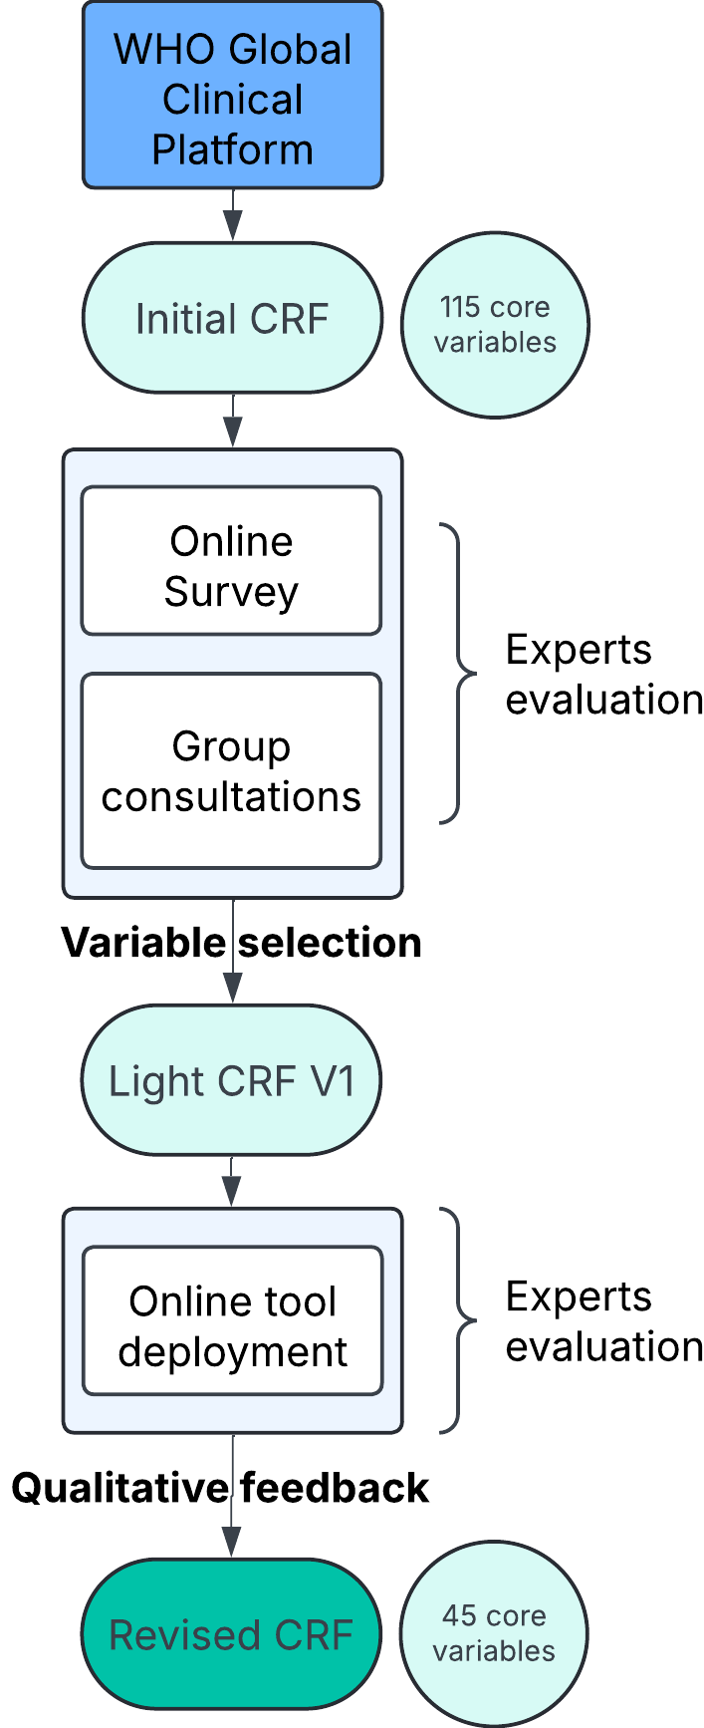

Annex B: Declarations of interest
Name | Declarations
Kayan Abukhaizaran | None
Ruhai Bai | None
Harlan Campbell | None
Orlando Cuellar | None
Ismael Diallo | None
Cristina Domingo-Carrasco | None
Pillaveetil Indu | None
Emilie Javelle | None
Yee Sin Leo | None
Lucy Lum | None
Maria-Lauretta Chito Orji | None
Louise Thwaites | None
Nicki Tiffin | None
Maria Esterlita V Uy | Indirectly participating in a study, and is the director of the institute receiving funding for dengue research although not part of the research team
Ananada Wijewickrama | WHO support dengue
Jie Yang | None

Annex C: Distribution of experts
The following shows the global distribution of experts (shading indicates at least one expert).
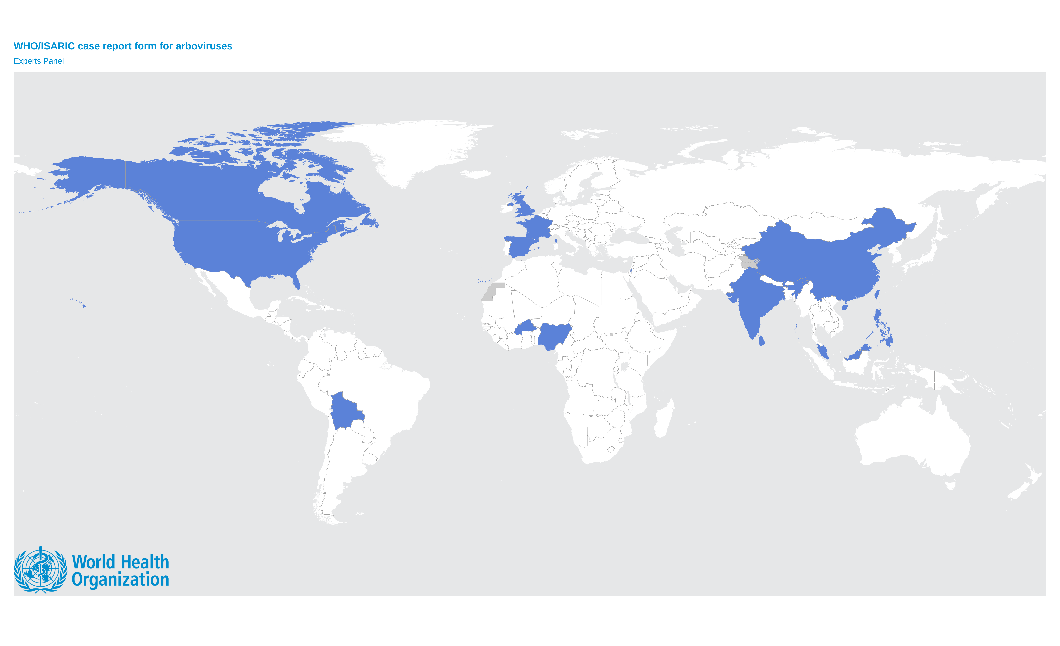
The boundaries and names shown and the designations used on this map do not imply the expression of any opinion whatsoever on the part of the World Health Organization concerning the legal status of any country, territory, city or area or of its authorities, or concerning the delimitation of its frontiers or boundaries. Dotted and dashed lines on maps represent approximate border lines for which there may not yet be full agreement.

Expert numbers by region
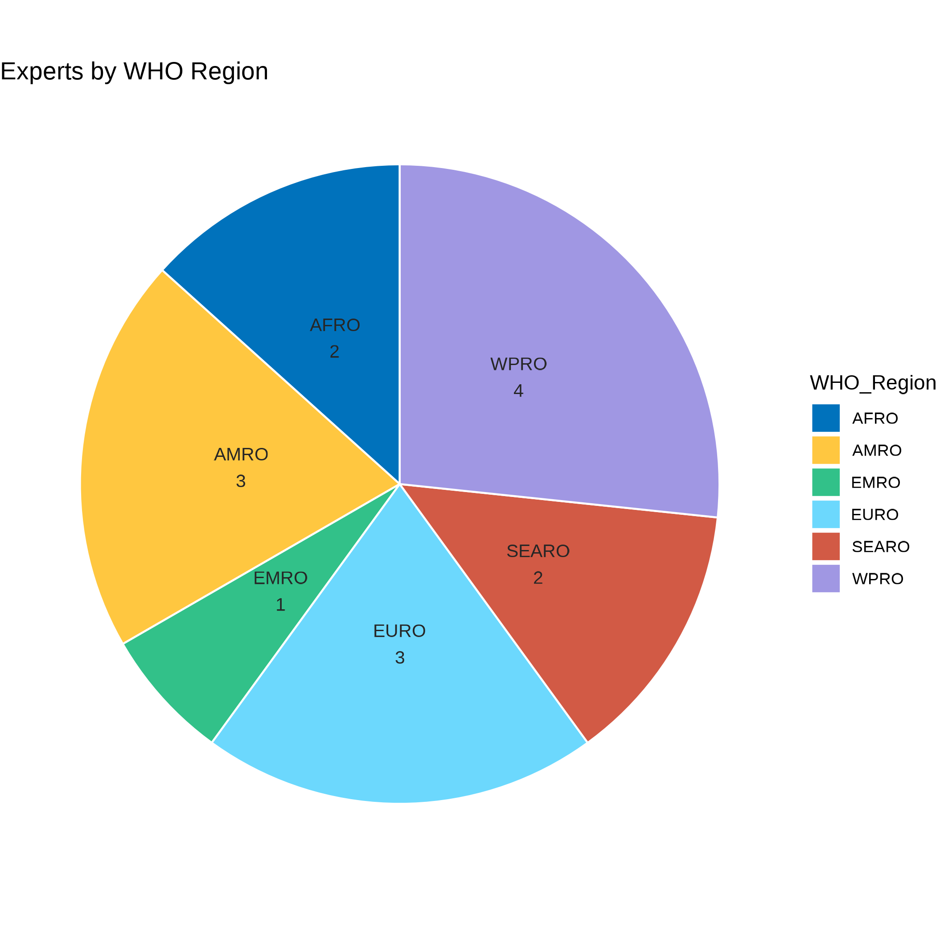
AFR: African region
AMR: Region of the Americas
EMR: Eastern Mediterranean region
EUR: European region
SEA: South-East Asia region
WPR: Western Pacific region

Annex D: Survey variables

Initial survey variables (before consensus group meetings)
Variable group | Count
Case Identification | 13
Complications | 20
Diagnosis | 5
Final Diagnosis | 6
Laboratory and Imagery | 14
Outcomes/Discharge | 7
Symptoms | 25
Treatments | 12
Vaccinations | 4
Vitals | 9
TOTAL | 115

Final consensus-agreed variables
Variable group | Main | With sub-questions
Diagnosis | 1 | 2
Hospital registration | 2 | 3
Demographics | 5 | 12
Vital signs at admission | 5 | 16
Symptoms at admission | 3 | 3
Existing medical conditions | 3 | 5
Vaccination status | 3 | 8
Pathogen testing | 2 | 4
Laboratory testing | 2 | 6
Complications | 11 | 27
Medications | 1 | 1
Treatments and interventions | 2 | 4
Outcome | 5 | 6
TOTAL | 45 | 97

Annex E: Survey results
The following are illustrative of the survey results which the expert group used as a basis for initial variable selection.
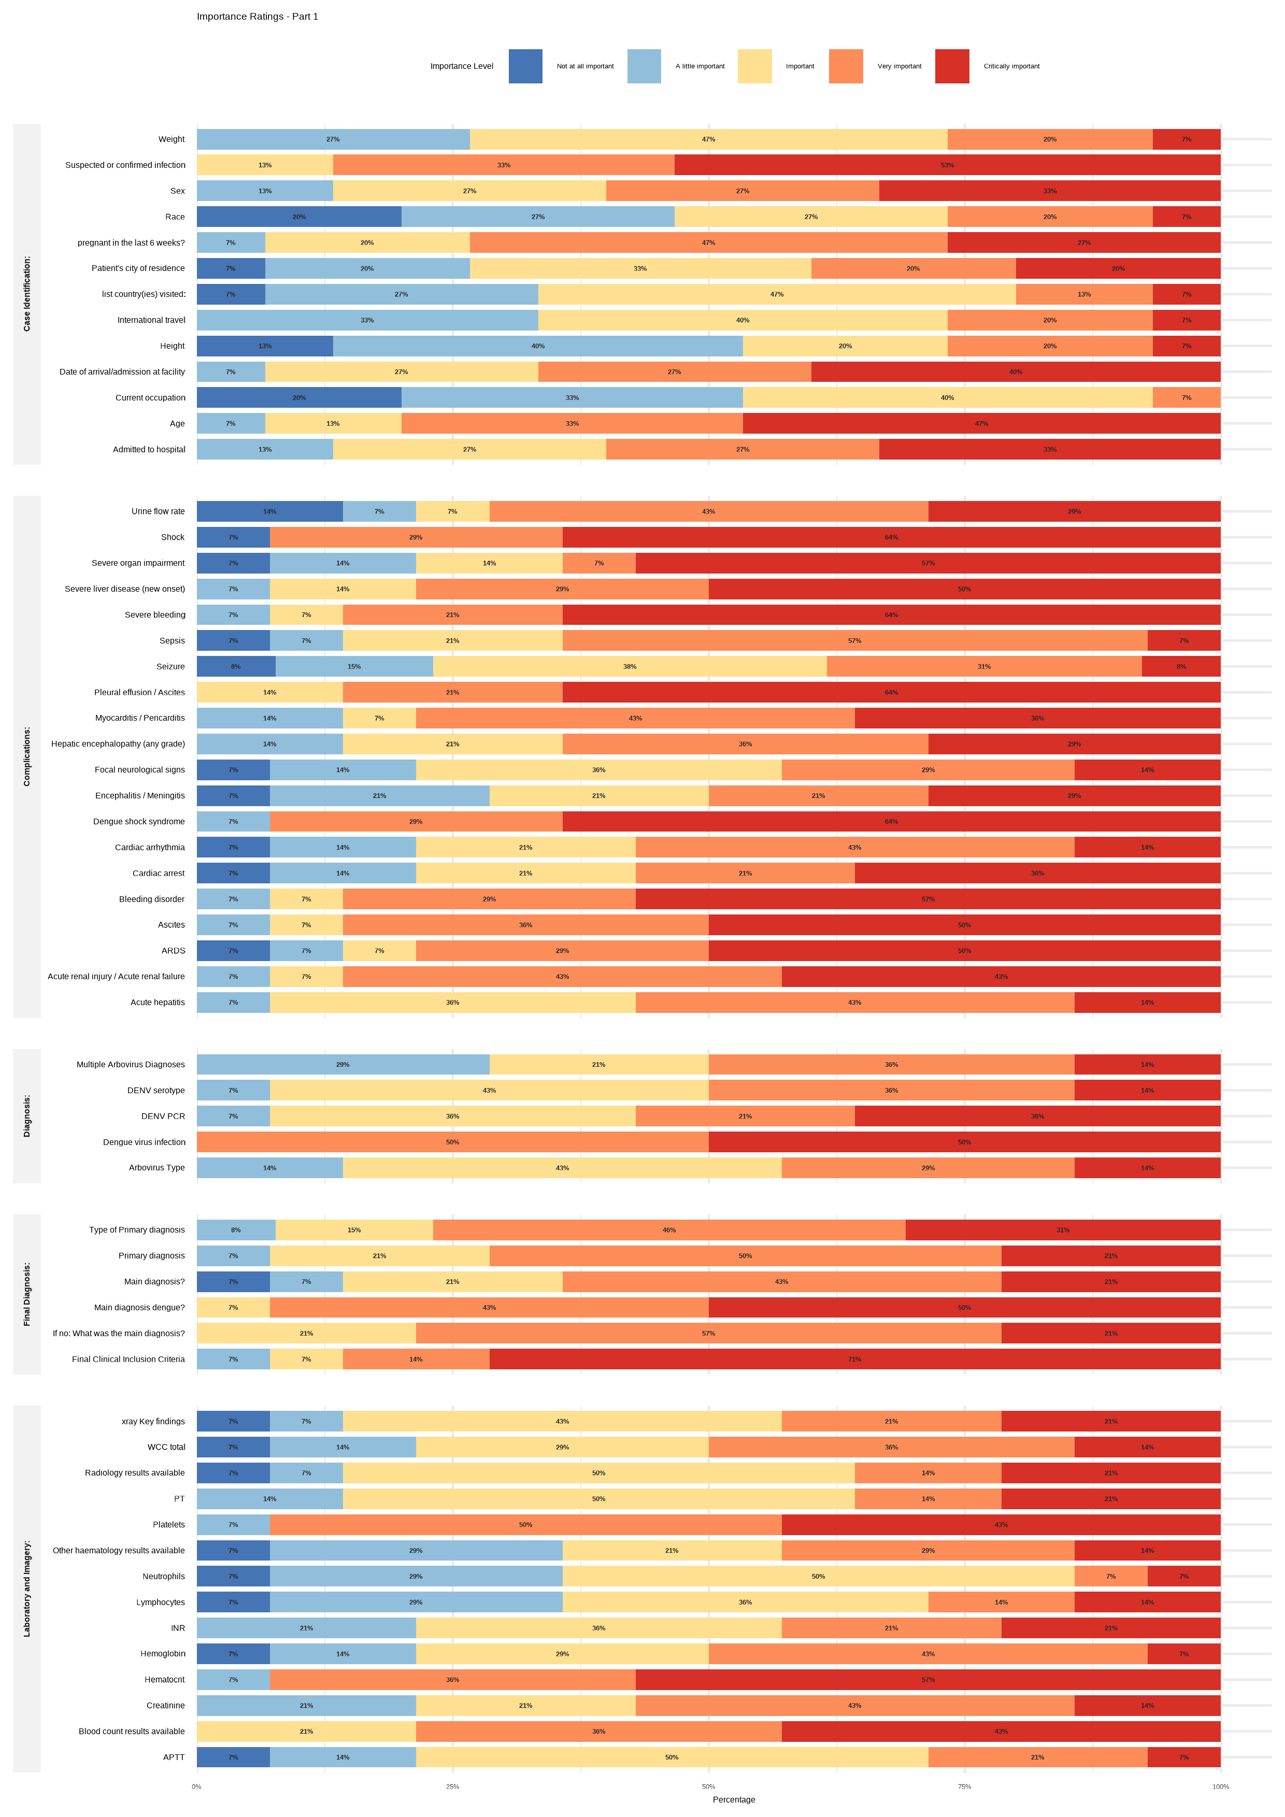

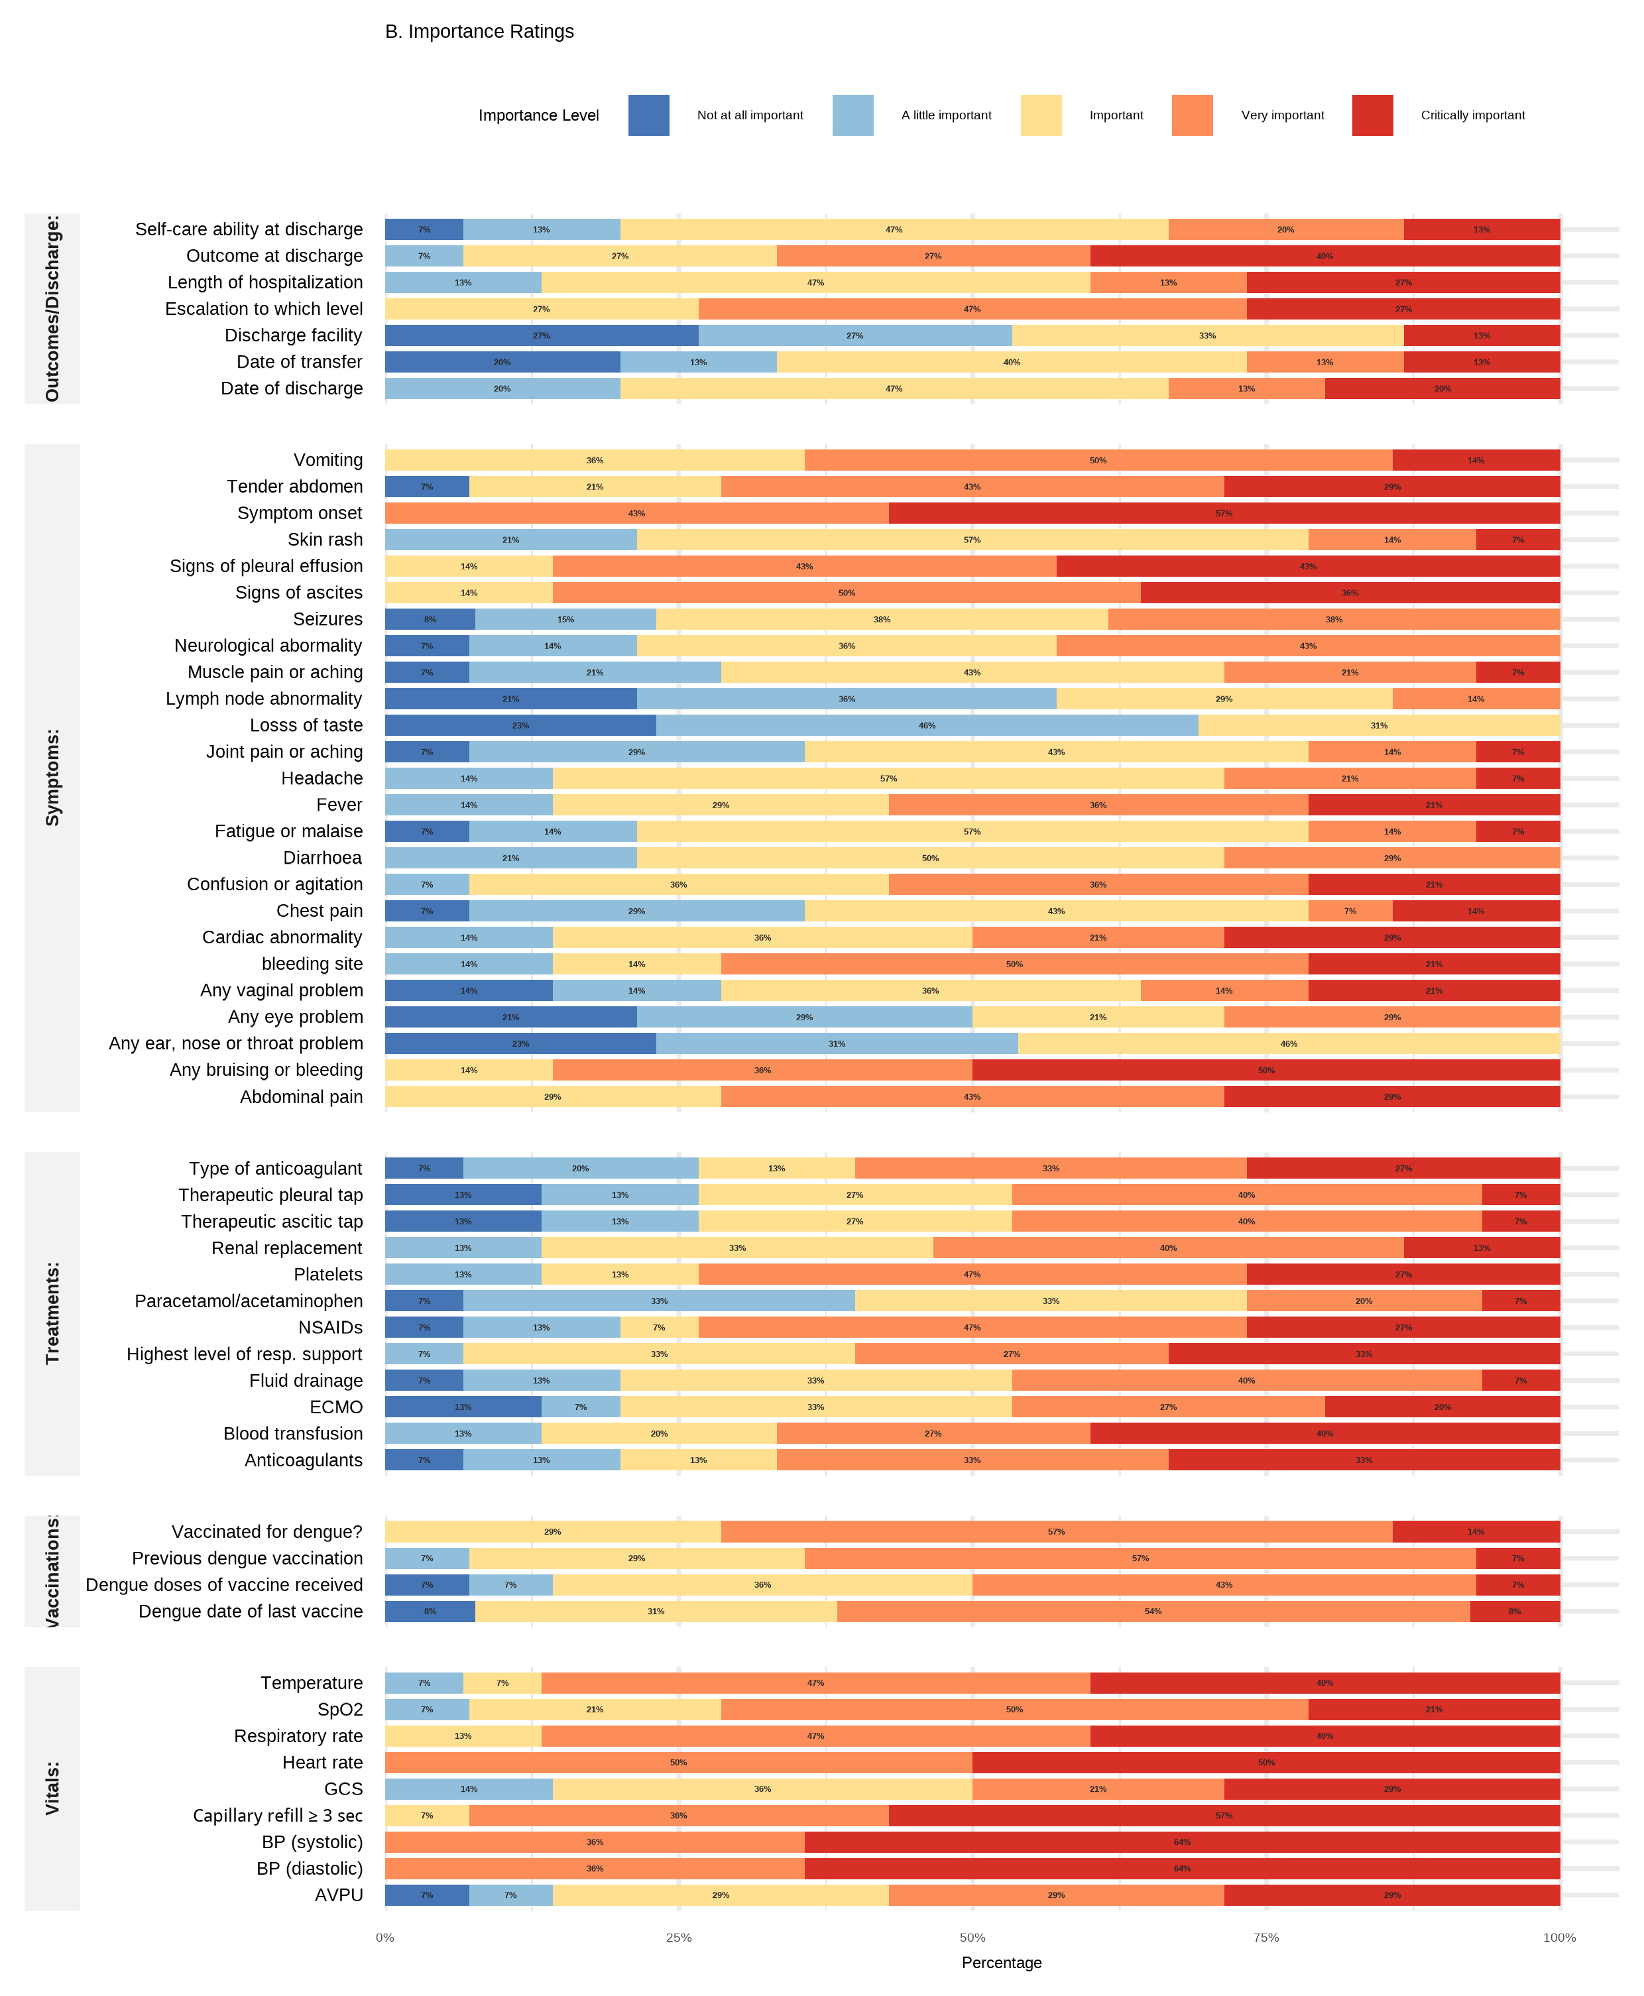

Annex F: Summary of proposed clinical surveillance tools

Aims
- Provide near real-time reporting of dengue infection outcomes amongst patients admitted to a healthcare facility for observation and/or treatment.
- Enable comparison of clinical outcomes over time, and between facilities, supporting benchmarking and identification of trends.
- Capture, present and track markers of clinical care to facilitate quality improvement as part of Plan-Do-Study-Act (PDSA) cycles or other quality frameworks.
- Facilitate data interoperability by providing a logical interface with existing clinical characterization tools and research platform.

What data?

Facility data to understand health system resource availability and use for treating patients with dengue:
- Detailed annual facility survey to define local capability and capacity.
- Daily online reporting of dengue patient numbers and bed utilization (suspected and confirmed) using a questionnaire of approximately 5 questions.

Dengue patient data to capture clinical characteristic, treatment and outcomes:
- For patients admitted to a facility with clinical suspicion of dengue, with or without diagnostic confirmation, a lightweight case report form collected at exit from the clinical facility (or at one week, if sooner). Approximately 25 variables will be included:
  - baseline demographics;
  - parsimonious markers of severity (for example shock, platelet count);
  - process markers of clinical care which are amenable to quality improvement.
- Linkage with laboratory results according to local capacity.

The project will deliver…
… a harmonised, lightweight, and near real-time clinical surveillance system for dengue that enables facilities and national programmes to monitor clinical outcomes and support care quality improvement.

Intended users
Clinicians and facility managers who seek to understand local patterns of disease, and to improve patient outcomes in dengue disease.
Health system leaders and Ministries of Health who wish to understand dengue burden, allocate resources, and promote good practice in dengue endemic or epidemic regions.
Regional and global health partners to support outbreak tracking and response coordination.
Researchers and technical networks to link clinical surveillance with more detailed research initiatives.

Key principles

Trusted and locally owned
- Immediate data ownership: Uploaded data
remain the property of end-users and are instantly accessible to them.
- Transparent and interoperable: Analysis code and data structures are openly documented and harmonized with relevant research networks wherever feasible.
- Secured infrastructure: Data are hosted on secure servers with strong authentication and access protocols.
- Local implementation: The platform can be deployed at the Members States level to comply with national data security requirements.

Quick to implement and use (lightweight)
- Limited data burden: Limited volume data collection.
- Seamless integration: Extraction from existing databases if possible.
- Adoption: Comes with standard operating procedures and implementation guidance to support adaptation and system integration.

Promoting end-user uptake of information
- Expertise: Designed by global experts to ensure data elements are relevant and clinically meaningful.
- Rapid automated analyses: Pre-defined workflow enables rapid and reliable/reproducible analysis/insights.
- Actionable dashboard: Stratified visualizations providefine-grained detail for facilities, alongside with openly available aggregated regional and global summaries.

Project timeline

December 2025: Finalise definitions and data
- Groups from WHO vertical programmes and representation of special groups.
- Existing collaborating sites and networks.

January 2026: Site identification for pilot
- Existing dengue networks (mid-volume centres ideal for pilot)
- Broad expression of interest for dengue clinical surveillance sites (member states, health facilities, research sites/networks).

March - May 2026: Pilot implementation
- Feasibility checking.
- Finalization of data pipeline.
- Creation of dashboard and reporting tools.

Annex G: Variable completion notes
Variable | Note (included in the form) | Definition / description / further clarification
FORM COMPLETION
Person completing the CRF | Person responsible for data completion | Person responsible for data completion
If other, specify who is completing the form:
DIAGNOSIS
Final clinical diagnosis at outcome assessment | Most recent primary diagnosis | At the point of data collection, what is the primary diagnosis, based on the available information
Specify | State the single most important diagnosis
Date of admission at facility | Admission to this facility | If the patient was transferred in from another facility, use the date for the current facility
Known date of onset |  | Is the date of onset of the first symptoms for the presenting illness known
Date of onset | Date of the first symptom of this illness | When was the first symptom of the illness for which the patient was admitted
DEMOGRAPHICS
Age |  | Age at first day of admission to this facility
Sex at birth
Pregnancy in the last 6 weeks? | Include pregnancy of any outcome | Current pregnancy or pregnant in the preceding six weeks (include pregnancy irrespective of outcome)
Height and weight measured or documented? |  | Is there a record of height and weight in the patient notes, documented in the previous 3 months.
Unit of height |  | In which unit was the height measured
Height (cm) | centimetres
Height (in) | inches
Unit of weight |  | In which unit was the weight measured
Weight (kg) | kilograms
Weight (lb) | pounds
Body Mass Index | Automatically calculated if height and weight available | Body Mass Index
VITAL SIGNS AT ADMISSION
Conscious level |  | Coding used for the first recorded level of consciousness. This should ideally be at admission, but if not available, a later assessment is allowed.
ACVPU (Alert, Confused, Voice, Pain, Unresponsive) | Use earliest available value. | The ACVPU scale is a first aid and emergency assessment tool to quickly gauge a person's level of consciousness, standing for Alert, Confused, Voice (responds to verbal), Pain (responds to painful stimulus), or Unresponsive (no response)
Glasgow Coma Scale (GCS) | Total GCS (3–15).  Use earliest available value. | The Glasgow Coma Scale (GCS) evaluates patient responses to a stimulus: (M) motor response; (V) verbal response; (E) eye-opening
Blood pressure measured or documented? |  | Blood pressure measured or documented. This should ideally be at admission, but if not available, a later assessment is allowed.
Systolic blood pressure (SBP, mmHg) | Use earliest available value. | Systolic blood pressure.  This should ideally be at admission, but if not available, a later assessment is allowed.  If the blood pressure could not be recorded because it was too low, enter zero.
Diastolic blood pressure (DBP, mmHg) | Use earliest available value. | Diastolic blood pressure.  This should ideally be at admission, but if not available, a later assessment is allowed.  If the blood pressure could not be recorded because it was too low, enter zero
Capillary refill measured or documented? |  | Capillary refill measured or documented at the time of admission
Capillary refill: |  | Time for color to return to the skin after pressure has been applied for 5 seconds
Heart rate measured or documented? |  | Heart rate measured or documented. This should ideally be at admission, but if not available, a later assessment is allowed.
Heart rate (/min) | Beats per minute. Use earliest available value. | Heart or pulse rate (beats per minute)
SpO2 measured or documented? |  | Peripheral oxygen saturation (SpO2) measured or documented. This should ideally be at admission, but if not available, a later assessment is allowed.
SpO2 (%) | Use earliest available value. | Peripheral oxygen saturation measured by pulse oximetry
SpO2 measured on oxygen |  | Was the patient on oxygen at the time the oxygen saturations were measured
Temperature measured or documented? |  | Body temperature, measured directly or by infrared, and taken according to local protocol
Temperature units |  | Units in which temperature has been measured.
Temperature (ºC) | Celsius | Temperature in degrees Celsius. This should ideally be at admission, but if not available, a later assessment is allowed.
Temperature (ºF) | Farenheit | Temperature in degrees Farenheit. This should ideally be at admission, but if not available, a later assessment is allowed.
SYMPTOMS AT ADMISSION
Tender abdomen observed or noted | on initial assessment | Pain or discomfort elicited by light or deep palpation of any part of the abdomen. This includes signs of rebound or guarding. This applies to findings on admission or initial assessment.
Palpable liver observed or noted | on initial assessment | Liver edge palpable below the costal margin (at any size). This applies to findings on admission or initial assessment.
Persistent vomiting observed or noted | on initial assessment (≥3 episodes/24h, or unable to retain fluids) | Three or more episodes of vomiting in 24 hours, inability to keep down oral fluids. This applies to findings on admission or initial assessment.
EXISTING MEDICAL CONDITIONS
Any existing chronic medical condition? |  | Any pre-existing physician-diagnosed condition requiring long-term medication or monitoring. Includes: diabetes, chronic kidney disease (CKD), heart disease, or asthma.
Hypertension |  | Documented history of BP ≥140/90 mmHg or current use of anti-hypertensive medication
Obesity |  | BMI ≥ 30.0 kg/m^2 or clinically documented as obese in medical records. For pediatric patients, use age-appropriate growth charts (> 95th percentile).
Diabetes |  | Include diabetes mellitus or any type.
VACCINATION STATUS
Vaccinated for dengue? |  | History of vaccination against dengue as recalled by the patient, or from medical records.
Known year of last vaccination?
…year of last vaccine |  | Year of last dengue vaccination
Known month of last vaccination?
…month of last vaccine |  | Month of last dengue vaccination
Vaccine doses received |  | Number of dengue vaccine doses received
PATHOGEN TESTING
Dengue PCR result known? |  | RT-PCR testing for dengue virus RNA, at any time in the admission.
Dengue PCR result | Unknown or inconclusive result can be used for any
Dengue serotype known? |  | Was a dengue virus serotype identified by any laboratory test
DENV serotype: | Select all that apply | Which which dengue virus serotype(s) was/were detected
LABORATORY TESTING
Hematocrit results known? |  | Has a hematocrit been measured at any time during this admission
First hematocrit (%) | Use earliest available value. | First hematocrit measurement during admission
Highest hematocrit (%) | Highest value during admission. If only one value available, the same value is used for first and highest measurement. | Highest recorded hematocrit measurement during admission. If only one value is available, the same value is used for first and highest measurement.
Platelet count result known? |  | Recording of any platelet count during this admission
First platelet count | count x10^3/µL or /mm^3. Use earliest available value. | First platelet count recorded during admission.
Lowest platelet count | Lowest value during admission. If only one value available, the same value is used for first and lowest measurement. | Lowest recorded platelet count during admission. If only one value is available, the same value is used for first and lowest measurement.
COMPLICATIONS
Any complication at any time during admission |  | Any medical complication during the admission. This includes secondary infections, organ failure, or severe haemorrhage.
Any observed or noted bleeding | At any time. Includes any abnormal bleeding (does not include menstruation) | Any bruising or bleeding which has been observed or diagnosed during the admission. This includes blood in stool (melaena or bleeding per rectum), nosebleed (epistaxis), abnormal bleeding from the sites of injections or needle sites, vomiting blood (hematemesis), coughing blood (haemoptysis); bleeding from mouth/gums; blood in urine (haematuria); abnormal bleeding from the vaginal (do not include typical menses/period)
Bleeding already present at admission?
Site of bleeding | Select all that apply | Specify all sites in which bleeding has been observed or diagnosed during this admission
Pleural effusion or ascites observed or noted | At any time. Include clinical or radiologically confirmed | Clinically detected (for example findings of stony dullness, decreased breath sounds, shifting dullness) and/or confirmed by imaging (ultrasound/chest X-ray).
Effusion or ascites already present at admission?
Need for oxygen at any time | At any time. SpO₂ <90% on room air oxygen administered. | Documented oxygen saturation < 90% on room air OR supplemental oxygen administered.
Need for oxygen present at admission?
Low systolic blood pressure | At any time. For adults systolic blood pressure <90mmHg; for children: < 70 + [2 × age in years] | Single or repeated measurement of systolic blood pressure < 90 mmHg. In pediatric patients, use age-specific hypotension definitions (e.g., < 70 + [2 × age])
Low blood pressure present at admission?
Cold extremities | At any time. | Hands and/or feet are cool or cold to the touch.
Cold extremities present at admission?
Abnormal capillary refill (>3s) | At any time. Capillary refill >3 seconds. | Return to baseline colour taking >3 seconds after applying pressure to the nail bed/finger pulp for 5 seconds.
Abnormal capillary refill present at admission?
Weak and fast pulse  [For children] | At any time. | Difficult-to-palpate peripheral pulse with a rate exceeding the normal range for age (tachycardia).
Weak and fast pulse present at admission?
Cardiac complications | At any time. Includes myocarditis, arrhythmia, heart failure. | New-onset arrhythmia, myocarditis (elevated troponin and/or compatible ECG changes), or clinical heart failure (as assessed by measures including jugular venous pressure, gallop rhythm, bilateral chest crackles, oxygen saturations).
Cardiac complications present at admission?
Acute liver injury | AST or ALT ≥1000 U/L or acute jaundice | AST or ALT > 1000 U/L OR jaundice with acute onset.
Liver injury present at admission?
Acute kidney injury (AKI) | Creatinine rise or low urine output. | Doubling of baseline serum creatinine OR low urine output (for adults < 0.5 mL/kg/hr for 6 hours; for children <1 mL/kg/hr for 6 hours)
Acute kidney injury present at admission?
Confusion, disorientation or abnormal mental status observed or noted | Any abnormal mental status, or seizure.  Exclude: Simple fatigue or weakness. | Any change from baseline mental status. Includes lethargy, irritability, drowsiness, or a Glasgow Coma Scale (GCS) score < 15.
Abnormal mental status present at admission?
Any other organ complications | Severe organ dysfunction not listed above. | Clinical or laboratory evidence of severe organ dysfunction not captured in previous questions.
If others, indicate type of other complications:
Other organ complication present at admission?
MEDICATIONS
Recent NSAID (non-steroidal anti-inflammatory drug) | In the 7 days before admission. | Use of prescribed or over-the-counter non-steroidal anti-inflammatories. This includes aspirin, ibuprofen, diclofenac and other NSAIDs. This is time limited to the week (seven days) immediately before admission.
TREATMENTS & INTERVENTIONS
Administration of any blood product | Includes any of: blood; platelets; plasma; cryoprecipitate; blood derived products; fibrinogen concentrate, at any time during admission. | Administration of any whole blood or blood component (e.g., packed red cells, platelets, fresh frozen plasma, cryoprecipitate) during this admission.
Which blood products were administered | Select all that apply | Types of blood products administered during this admission.
Fluid drainage procedure performed? | Includes removal of pleural or abdominal fluid. | Has a medical procedure been performed to remove fluid from around the lungs or abdomen
Reason for fluid drainage | Select one | Select the primary site where the invasive procedure (e.g., tap or drain) was performed. If both occur, select the site with the largest volume drained.
OUTCOME
Vital outcome |  | The survival status of the patient at the conclusion of the case report. This should be assessed at whichever occurs first, either: 1) at discharge or release from the facility, or; 2) seven days after admission to the facility if admission is ongoing, or; 3) at death.
Date of death | Leave blank if unknown | Calendar date of death
Outcome at the time of assessment | At day 7 of admission, or discharge if sooner. | This should be assessed at whichever occurs first, either: 1) at discharge or release from the facility, or; 2) seven days after admission to the facility if admission is ongoing, or; 3) at death.
Destination after leaving facility |  | Destination of the patient after leaving the facility.
Mode of discharge |  | Type of patient discharge
Date of outcome assessment | Date outcome information recorded. | Date at the point of data collection (or at 7 days after admission to the hospital, whichever is the soonest)

